22nd October 2009
EXPERIMENT 9
NEWTON’S LAW OF COOLING FOR A LIQUID
AIM
The aim is to prove Newton’s law of cooling true.
APPARATUS
- Small calorimeter with open top
- Stirrer
- 2 thermometers (0⁰C - 100⁰C)
- Stand with clamp
- Stopwatch
- Large beaker
- Burner
DIAGRAM
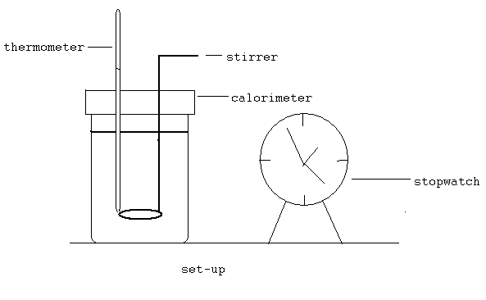

THEORY
Newton’s law of cooling states that for small difference of temperature between a body and the surroundings, the rate of gain or loss of heat by the body is proportional to the difference in temperature between the body and the surroundings. This means that if the temperature difference, t, between the two bodies is not too large, the rate of change of the temperature difference is nearly proportional to that temperature difference:
[1]
(d/dt)DT_{o} = - K DT
If at some time t = 0 the temperature difference is To, then at a later time t the temperature difference will be:
[2]
DT_{o} = DT e^{-KT}
This can be shown by integrating equation 1.
Therefore, when two bodies exchange energy thermally, the temperature of each will exponentially approach their common final equilibrium temperature.
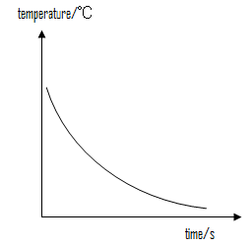

When a graph of slopes taken from six different points and excess temperature are plotted, a straight line graph passing through origin will be obtained proving Newton’s statement concerning the proportionality. Since the heat lost per second by the water and calorimeter is proportional to the rate of fall of the temperature, Newton’s law is thus verified.

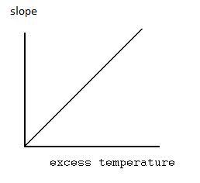

PROCEDURE
The calorimeter was placed on a bad conductor (the working bench) near a ceiling fan. Water in a beaker was heated over a burner to 90⁰C. The calorimeter was then filled with the hot water to about one centimeter from the brim of the calorimeter. The stirrer was placed in the hot water in the calorimeter and the thermometer likewise (being held by a clamp). Another thermometer was clamped near the calorimeter to record the temperature of the surrounding. Keeping the water cooling well stirred, the temperature was recorded at one minute intervals down to 35⁰C which is the end of the experiment. Again, the temperature of the surrounding is recorded.

OBSERVATION (TABLE OF RESULT)
Time / min | Temperature θ/⁰C
0 | 90
1 | 88
2 | 85
3 | 83
4 | 81
5 | 79
6 | 77
7 | 75
8 | 74
9 | 72
10 | 71
11 | 69
12 | 68
13 | 67
14 | 66
15 | 65
16 | 64
17 | 63
18 | 62
19 | 61
20 | 60
21 | 59
22 | 58
23 | 57
24 | 56
25 | 55
26 | 54
27 | 54
28 | 53
29 | 52
30 | 52
31 | 51
32 | 50
33 | 50
34 | 49
35 | 49
36 | 48
Time / min | Temperature θ/⁰C
37 | 48
38 | 47
39 | 47
40 | 46
41 | 46
42 | 45
43 | 45
44 | 44
45 | 44
46 | 44
47 | 43
48 | 43
49 | 43
50 | 42
51 | 42
52 | 41
53 | 41
54 | 41
55 | 40
56 | 40
57 | 40
58 | 39
59 | 39
60 | 39
61 | 38
62 | 38
63 | 38
64 | 37
65 | 37
66 | 37
67 | 37
68 | 36
69 | 36
70 | 36
71 | 36
72 | 35

CALCULATIONS

θ₀ = mean temperature = 28.5⁰C
Slope at 75⁰C =$\frac{78-70}{10-4}=1.33$

Slope at 60⁰C =$\frac{64-56}{24-16}=1$
Slope at 50⁰C =$\frac{52-46}{37-28}=0.67$

Slope at 46⁰C =$\frac{47-44}{43-38}=0.6$

Slope at 41⁰C =$\frac{43-38}{58-47}=0.45$

Slope at 38⁰C =$\frac{37-34}{74-64}=0.3$

Slope ⁰C/min | θ-θ₀ /⁰C
1.33 | 46.5
1 | 31.5
0.67 | 21.5
0.6 | 17.5
0.45 | 12.5
0.3 | 9.5

DISCUSSION
After the procedure was followed a graph was drawn up with the temperature as ordinate and the time as abscissa. This produced a curve known as the Newton’s cooling curve. This curve proved quite smooth in the first few temperature reduction but getting to the end was ‘unstable’ or consistent. When a graph of the slope at six points on the first graph against the corresponding θ-θ₀was drawn, it produced a straight line with almost all the points passing through the line although the line did not pass through the (0,0) point. The straight line shows that the rate of loss of heat is proportional to the excess temperature at any instant.

SOURCES OF ERRORS
- The water used contained some impurities which affected the boiling point of the water and the readings as well.
- Certain temperature reading s were not accurate but were rounded-up figures and this could affect the cooling curve graph drawn.
PRECAUTION
- The water was well stirred throughout the whole experiment to ensure an even distribution of heat in the water.
- Temperatures were read from a horizontal position (no parallax was allowed)

CONCLUSION
Newton’s law of cooling of a liquid (water) was verified.

REFERENCE
NELKON & PARKER: Advanced Level Physics 7th edition, New Delhi, CBS Publishers and Distributors, 2002. Pages: 636 – 637.

